2015 theme:
Lightbulb Moments that Show the Way
Personal Insights In Action

The Accounting MOVE Project measures and supports the advancement of women in public accounting. The AFWA is an association partner with MOVE.

Accounting MOVE Project 2015 Key deadlines:
- November 20, 2014: Webinar: Insights from MOVE firms
- December 22, 2014: Deadline for signing up
- January 30, 2015: Deadline for completing MOVE survey
- May 2015: MOVE executive summary in Public Accounting Report
- June 1, 2015: Best Public Accounting Firms for Women & Full MOVE report released
- June 17, 2015: Confidential firm scorecards and snapshots released

How MOVE Works
- Proven and promising practices relevant for firms of all sizes
- Career insights that provide context for individual women
- Results published in Public Accounting Report in May and in full in June
- Best Public Accounting Firms for Women list sponsored by AFWA and AWSCPA
- Comprehensive, confidential survey and interviews

- Confidential report to each participating firm
- Administrative fee scaled to firm size
- Participation and signup details:
http://wilson-taylorassoc.com/move/accounting

How You Can Help
- Encourage your firm or the firm(s) used by your organization to join MOVE today!
- Share your ‘lightbulb’ moment with the MOVE team: move@wilson-taylorassoc.com

Highlights from the 2014 Accounting MOVE Project
Women comprise:
- 51% of employees at American CPA firms
- 51% of the managers
- 44% of the senior managers
- 19% of partners/principals/leaders
- 19% of management committee members
Key takeaways:
- Firms can actually turn a profit from their women’s initiative
- Rothstein Kass gained $6.5 million in new revenue in 3 years directly from its Rainmakers Roundtable program
- The key: sync skills training with business development experience
- The most important metric to track: retention of partner-track women

For more details:
Joanne Cleaver President, Wilson-Taylor Associates, Inc.
231.299.1275 jycleaver@wilson-taylorassoc.com

Founding sponsor: Moss Adams National sponsor: CohnReznick
Association partners: Accounting & Financial Women’s Alliance
American Woman’s Society of CPA’s

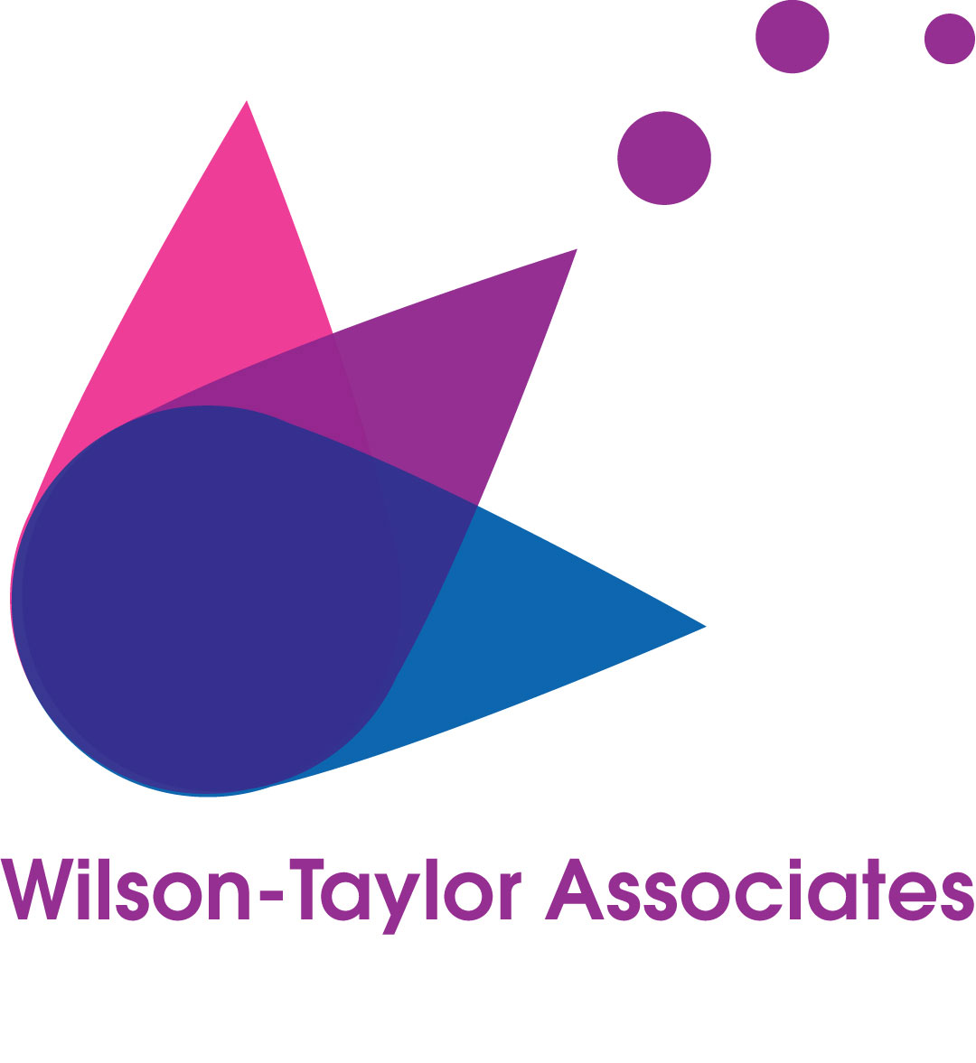
Women’s Development Is Business Development

The Business Case for Advancing Women in Public Accounting

Women: The Overlooked Growth & Profitability Driver

Women comprise 51% of public accounting firm employees, but 19% of firm partners and principals. - 2014 Accounting MOVE Project

Fewer women are entering public accounting. In 2002/03, women comprised 56% of new accounting grads (B.A. and M.S. combined). In 2012/13, they comprised 48%. – AICPA 2013 Trends in Supply of Accounting Graduates

Accounting and finance jobs are the fifth-hardest to fill. – 2013 Manpower Talent Shortage Survey

Accounting firms’ demands for new hires is expected to continue at its current pace, as firms seek to hire both for growth and to replace retiring baby boomers. – AICPA 2013 Trends in Supply of Accounting Graduates

Women comprise 61.3% of the 1.814 million American accountants and auditors. - Bureau of Labor Statistics, 2012

The larger the firm, the smaller the proportion of women at the top. Women comprise 20% of equity partners at firms with annual revenues over $25 million but 25% of equity partners at firms with annual revenues of $1 million to $5 million. – AICPA

As women progress in their public accounting careers, work-life balance and flexible work options rise in importance. Work-life balance is key to the retention of 63% of women managers (but important to 50% of women senior staff) while flexible work benefits are key to 54 of women managers (compared to 43% of women senior staff). – 2013 Accounting MOVE Project Report

Women comprise 11.4% of chief financial officers at Fortune 500 companies. – Catalyst

Women are over 50% of all managers, but only 4.6 percent of CEOs of Fortune 1000 companies are women. Here is the list from Catalyst.

Women on Boards Drive Better Results

Fortune 500 companies with the most women board members outperformed those with the least by:
- 16% for return on sales
- 26% for return on investment
- Catalyst

Fortune 500 companies with three or more women board directors outperformed those with zero women board directors by:
- 84% for return on sales
- 60% for return on investment
- 46% for return on equity
- Catalyst

On average, companies with three or more women on the board have a market capitalization three times greater than that of companies with no women board members. – Credit Suisse

Companies with at least one woman on the board outperformed companies with no women by 26 percent over the last six years. The difference occurred since the 2008 recession: gender diversity correlated with rocky markets, with those companies delivering higher return on equity and more even earnings. - Credit Suisse, 2013

Successful acquisitions cost 15.4 percent less with each female director added on a board. And each additional female director reduces the number of companies’ attempted takeover bids by 7.6 percent, minimizing risk and focusing acquisition strategy. – University of British Columbia, Director Gender and Mergers and Acquisitions

- 16%: the average return on equity of companies with at least one woman on their boards
- 12%: average return on equity of companies with no women on their boards
– Credit Suisse

- 14%: average net income growth for companies with at least one woman on their boards
- 10%: average net income growth for companies with no women on their boards
- Credit Suisse
Investing in Women Leaders Pays Off

Companies improve performance when they have more women in leadership.

Researchers compared S&P 1,500 companies with themselves over a 15 year period and found that, overall, “the data suggest[s] that firms that promote women to senior management positions enjoy economically superior performance because of the complementary set of interpersonal management skills related to inclusiveness and the encouragement of employee voices that women bring to the table.”
– Columbia Business School

“25 of Fortune 500 firms that most aggressively promoted women to executive positions had 34 percent higher profits as a share of revenue than the industry median.”
- Roy Adler/Pepperdine University

A Catalyst study on the financial performance of Fortune 500 companies with three or more women board directors outperformed those with zero women board directors by 84 percent for Return on Sales; 60 percent for Return on Investment; and 46 percent for Return on Equity. The same study showed that companies with the most women board directors outperformed those with the least by 16 percent for Return on Sales; and 26 percent for Return on Investments. – Catalyst

“Women are less likely to stay at companies (and industries) that do not value, respect and appreciate their talents. Women must see evidence of active processes to improve the hiring, retention and development of female managers. It also includes having gender friendly work policies.” – Gallup/Cambridge University and Elevating Women Leaders

Women Are Key Consumers and Business Decisionmakers

46% of U.S. privately held firms are at least half owned by women. – “High Achievers: Recognizing the Power of Women to Spur Business and Economic Growth,” EY

Women own a third of all businesses worldwide. – “High Achievers: Recognizing the Power of Women to Spur Business and Economic Growth,” EY

By 2028, women will control 75% of discretionary spending worldwide. – “High Achievers: Recognizing the Power of Women to Spur Business and Economic Growth,” EY

“Between 1970 and 2009, women went from holding 37 percent of all jobs to nearly 48 percent. That’s almost 38 million more women. Without them, our economy would be 25 percent smaller today – an amount equal to the combined [gross domestic product] of Illinois, California and New York.” – WSJ Executive Summary

Architects of Advancement
The Consultants and Coaches Who Drive Measurable Change for Women at Public Accounting Firms

These coaches and consultants are the behind-the-scenes ‘brain trust’ delivering proven results for many of the accounting firms that participate in the MOVE Project. These coaches and consultants either specialize in accelerating growth of women or have substantive experience in working with women at accounting firms.

Melissa McClenaghan Martin
M3 Strategic Alliances
212.737.5025 melissa@m3strategicalliances.com
www.m3strategicalliances.com

For: Designing a women’s initiative that focuses on business results and that accelerates the advancement of women to partner. Melissa is the architect of the Rothstein Kass “Rainmakers Roundtable,” which has increased the firm’s proportion of women partners by 15% in three years, as well as adding millions in top-line growth. She is also the architect of the RK annual study of women in alternative investments, which has elevated RK’s reputation with its core market.

Anne Perschel
Germane Consulting 508.799.9595
aperschel@germaneconsulting.com
Germaneconsulting.com
For: Training program that equips men to effectively mentor women. This approach, developed by Anne, a psychologist, neutralizes several dynamics that often derail mentoring programs at firms where there are many more male leaders than women leaders.

B+B Marketing and Communications, Wendy Traschen, principal, wtraschen@bolgerandbattle.com, 989.835.8171
www.bolgerandbattle.com
For: Implementing Diversity & Inclusion communications that drive positive personal, professional and organizational change. B+B is a full-service marketing and communications firm that crafts inspiring creative work anchored by strong strategy for clients that include Fortune 50 companies, regional accounting and professional firms and non-profits. Our experience includes employee communication campaigns – local, regional, national and global; communication strategies; recruiting campaigns; Diversity & Inclusion workplace award applications; strategic change management communications for human resources; leadership development communications; employee recognition programs; and executive speechwriting and webinars.

bbr marketing, Bonnie Buol Ruszczyk, president
bonnie@bbrmarketing.com, 404.423.4433

For: Marketing and website strategy and development, especially for social media strategy and training that is both engaging and legally compliant. Bonnie Buol Ruszczyk and her experienced staff understand how to help accountants, attorneys, engineers and other consultants reach their audiences and grow their firms through strategic marketing, website development, social media training and other content strategy.

Ghost CEO, Debbie Whitlock, Seattle Practice area
www.ghostceo.com
206-579.0249 debbie@ghostceo.com
For: Coaching and challenging women candidates for partner, and women partners, in business development skills
Ghost CEO brings a proven track record of business success, the ability to educate a diverse clientele on how to do sustainable business development, be part cheerleader and part task master. Debbie Whitlock serves an international client base; bringing 18 years of business savvy with a strong emphasis in the financial services industry.

And finally, last but certainly not least:

Wilson-Taylor Associates, Inc.
Joanne Cleaver
231.299.1275 jycleaver@wilson-taylorassoc.com
www.wilson-taylorassoc.com
For: Media training, message development and communication training for subject matter experts, partners, and communication staff
Finding the right words for on-the-record interviews isn’t hard when you use the Wilson-Taylor method for quickly framing and delivering key messages. Our workshops help subject matter experts, partners and practice leaders quickly and confidently know what to say and how to say it, when conducting on-the-record interviews. Our communication and media training programs and coaching have equipped women at Rothstein Kass and other firms to make the most of media opportunities in publications such as FINS (the Dow Jones financial news channel), USNews.com and The Glass Hammer.

8.14/jyc

